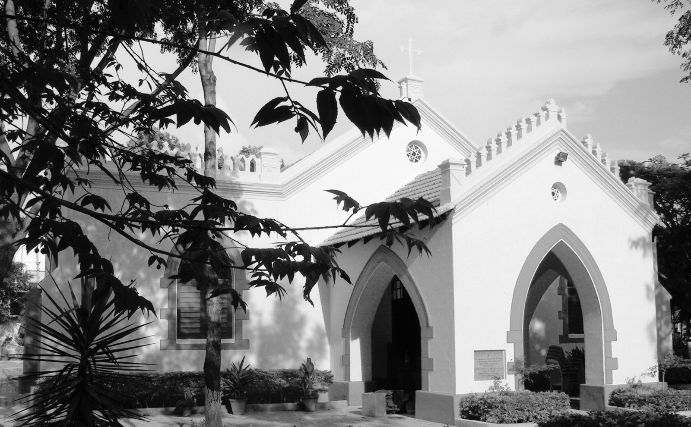

Welcome to Memorial Church Anglican

**The Tenth Sunday after Trinity (Service for Our Nation)**

**20th August, 2017**

“But Seek Ye First the Kingdom of God and his Righteousness; and All these things shall be added unto you.”

St. Matthew. 6:33.

**www.memorialchurchanglican.com**

**Anglican Practices at Worship**

We Anglicans have a set form of Worship. These forms have been practiced for over four hundred years.

When we enter the Church, we **GENUFLECT** or make a deep **BOW** from the waist as the Blessed Sacrament is reserved in the **Tabernacle** of the Church. You will see a Red Light burning near the Tabernacle to denote it’s presence.

We **BOW** when the name of “Jesus” is mentioned in the Prayers and Readings. We Bow before we kneel at the Altar railing for receiving the Holy Eucharist and before we return.

We say **Amen** when the Celebrant hands the sanctified Host and then alone consume it. We say Amen once again after we have consumed the sanctified Wine. The meaning of **“Amen”** is“So Be It” or “Agreed”.

We **SIT** for the hearing lessons from the Old Testament and New Testament, Psalms(when it is not sung), Announcements and Sermons/Homilies.

We **STAND** for singing of Hymns, saying the Gloria at the end of the Psalm, saying the Creed, hearing the Holy Gospel, and for the Gloria in Excelsis at the end of the Worship.

We are on our **KNEES** for all prayers. We consider standing for prayers as disrespect to our Almighty God, our Creator.

When we leave after the Worship we once again **GENUFLECT** or make a deep **BOW** from the waist.

Traditional Anglicans in our Parish place the **Sign of the Cross** (in different ways) at various parts of the Worship. In case you are keen to learn these practices please approach anyone of them, they would be delighted to teach you.

God, Bless You…

Cecil K. Dewars

MEMORIAL CHURCH ANGLICAN

CIPBC

WHITEFIELD- BANGALORE

CONSECRATED 1886

**Announcements for the week:**

* Our Metropolitan and Bishop, His Grace John Augustine, along with his wife will be visiting us from the **12th-15th September**.
* On the **13th September**, we are planning a Parish dinner, so that we can all meet His Grace. All are welcome. Please give in your names if you would be attending, latest by **3rd September** after the Holy Mass.
* On the **14th September,** is the Confirmation Service at **10:00 a.m.** Please continue to uphold the Catechumens in your prayers.
* Please do join us for coffee

**Next Sunday:**

The Lessons and the Readers for the following Sunday are:

1. Old Testament Lesson: **1 Kings 3:5-15**

Reader: Jeeth

1. Psalms : **119: 81-88**

Reader: Sarah Daniel

1. New Testament Lesson: **1 Corinthians 15:1-11**

Reader: Monisha

1. Intercession

Reader: Cecil K. Dewars

-----------------------------------------------------------------------------------

**Daily Prayer:**

**Matins:** 08:30 Tuesday through Saturday.

**Sext:** 12:00 Tuesday through Saturday. On Friday the Priest will also Bless authorised​​ Religious Items - even for the Laity.

**Vespers (Evensong):**18:00 Tuesday through Friday and on Sunday

-----------------------------------------------------------------------------------

Vicar: Rev. Fr. Suthi Gabriel

Telephone: +91 7022764324

E-mail: [**vicarmca@gmail.com**](mailto:vicarmca@gmail.com)

Processional Hymn 10

Vicar’s Address

National Anthem

National Prayer Romola Kuruvilla

Remembrance Margaret Lunel

Solo Rachel

Responsive Prayer Mary Priya

Old Testament Lesson Deuteronomy 10:17-22

Reader: Grace

New Testament Lesson Hebrews 11:8-16

Reader: Nimalan Paul

Solo Sarah Daniel

The Holy Gospel St. Matthew 5:1-12

The Apostles’ Creed

The Sermon                            Vicar

Offertory Hymn 312

The Intercessory Prayer Vicar

Hymn of Faith

Prayer for the Church George Kuruvilla

Prayer for our Country Wilson Bright

The Lord’s Prayer

Act of Dedication

The PAX

Recessional Hymn 355

**--------------------------------------------------------------------------------**

**Biblical Verse for the Week: Jesus said,** Blessed are the peacemakers: for they shall be called the children of God.

**--------------------------------------------------------------------------------**

2